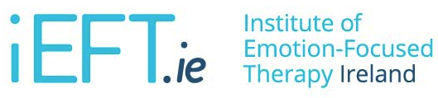

Emotion-Focused Therapy - Level 2
26th - 29th January 2017
Centre for Professional Therapy, Baggot St., Dublin
(€550 / €500 early bird rate before 09/11/2016)

REGISTRATION FORM

NAME:

EMAIL:

PHONE:

QUALIFICATION:

REGISTRATION:
(Please provide details of registration or accreditation as appropriate)

PAYMENT DATE:
(Please provide details of payment
made to account below
e.g. reference name/number)

INVOICE
EMPLOYER DETAILS:
(Where an invoice is required as payment is being made by employer, please provide employer/workplace details as appropriate)

Please make payment to the following account

Account Name: Institute of Emotion Focused Therapy Ireland
Bank: Bank of Ireland, 2 College Green, Dublin, Ireland
Account Number: 88635325
Sort Code: 900017
Bank Identifier (BIC): BOFIIE2DXXX
IBAN: IE15BOFI90001788635325

Registration is on a first come, first served basis. No refund will be given without one week’s notice of cancellation.

The Institute of Emotion Focused Therapy, Ireland is an accredited isEFT institute.
www.ieft.ie | www.iseft.org

